Vintner’s Pyment

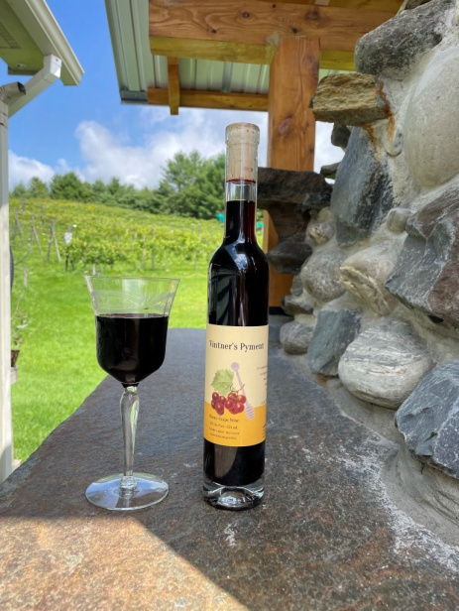

Honey – Grape Wine

Vintage: 2022 / 2023

Grape Varieties: Organic Sabrevois and Frontenac

Honey: Raw Wildflower - Northwoods Apiaries

Region: Montpelier, Vermont

Alcohol: 12 %

Winemaking Notes: The Sabrevois grapes were foot-crushed and naturally fermented on their skins, while the Frontenac grapes were pressed and fermented separately. Local honey was then added to both batches, which underwent several weeks of fermentation before being pressed. Afterward, the two were blended and aged in Hungarian oak barrels for nine months before bottling.

Tasting Notes: This wine has good clarity but is very dark from the red grapes used to make it. The aroma is primarily dark fruits: currants, black raspberries, loganberries, and lingonberries. Flavors of cherry and black raspberry are complemented by toasted marshmallow and vanilla. Lingering acid and mild tannicity balance out the sweetness in the mouth and on the aftertaste

Total Production: 8 cases

