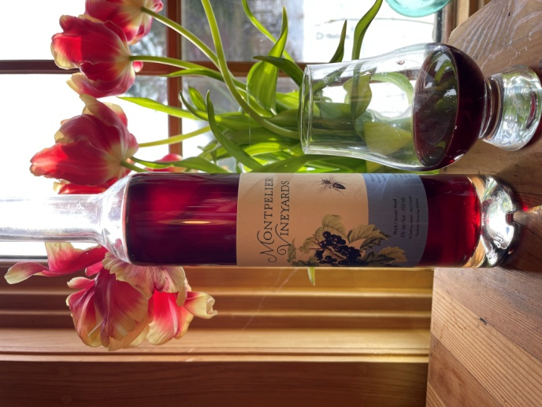Black Currant Mead

Vintage: 2023

Organic Black Currents: Sourced from Old Man Wine Company Middlesex, Vermont

Raw Honey: - Northwoods Apiaries Westfield, Vermont

Region: Central Vermont

Alcohol: 11 %

Winemaking Notes: Handpicked in July, the black currants were combined with honey and spring water, then left to ferment for several months before being pressed. Following fermentation, the wine was aged in glass demijohns for 18 months prior to bottling.

Tasting Notes: This wine offers a luscious bouquet of dark berries and floral honey, complemented by a pleasant acidity that balances its natural sweetness. It pairs beautifully with rich dishes, aged cheeses, or desserts like dark chocolate, but is equally delightful on its own for special occasions. The finish is smooth and lingers gracefully.

Total Production: 19 cases