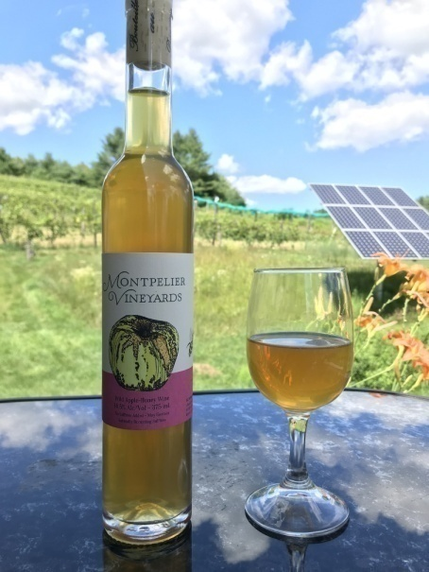Wild Apple Honey Wine

Vintage: 2023

Cider: Sourced from a variety wild and heirloom trees at Montpelier Vineyards

Honey: Raw Vermont - Northwoods Apiaries

Region: Vermont

Alcohol: 12.9 %

Winemaking Notes: The apples were pressed in October, mixed with the honey and naturally fermented using the wild yeast on the fruit. After fermentation, the wine was aged in glass demijohns for nine months before it was bottled.

Tasting Notes: Primary aroma of apple, with undertones of floral honey and cinnamon. Moderately sweet with acid and tannin from apples. Very soft palate tannins and excellently clean wild fermentation. Some other interesting esters such as vanilla and mulling spices are noticeable from the wild yeast on the palate. Finish is smooth and long lasting.

Total Production: 14 cases

