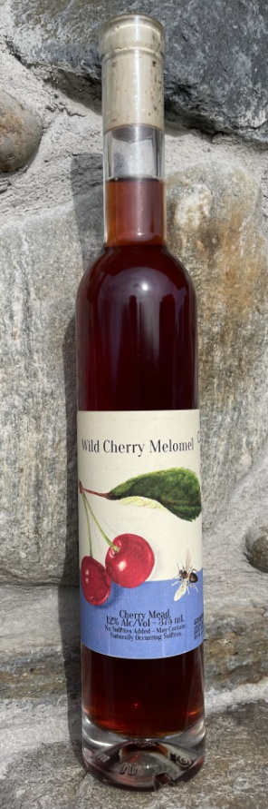Cherry Mead

Vintage: 2023

Fruit: Foraged Chokecherries - Prunus Virginiana

Honey: Raw Wildflower - Northwoods Apiaries

Alcohol: 14 %

Winemaking Notes: Chokecherries, also known as bitter-berry, were added to raw honey and spring water, fermented for several weeks and then pressed. Fermentation continued in glass demijohns for ten months before the finished product was bottled.

Tasting Notes: This mead was made with local raw honey and chokecherries from our Washington, Vermont site. It has an orange-red color and crystal clarity. On the nose, cherries dominate with floral undertones of the honey. On the palate, bitterness from the chokecherries appears first, followed by a strong sweetness, and flavors of red fruits, although not distinctly cherry. A tannic puckering is present in the mouthfeel, followed by an earthy aftertaste and lingering bitterness.

Total Production: 12 cases

